

**ASSIGNMENT 3**

|  |  |  |
| --- | --- | --- |
| Subject | : | Technology and Information System (SECP1513) |
| Session | : | 2023/2024 Semester 1 |
| Task | : | REPORT on INDUSTRY TALK 2 |
| Title | : | System Development @ Credence (TM Subsidiary) |
| Duration | : | 10 Days (1 January 2024 until 10 January 2024  before 12.00 am) |
| Submission | : | This is a **GROUP WORK** and submit it **INDIVIDUALLY** |
|  |  | a. Upload a report (in .pdf format) via UTM E-learning  b. Upload a report (in .pdf format) via GitHub (**A WEEK** after a submission through UTM E-learning) |

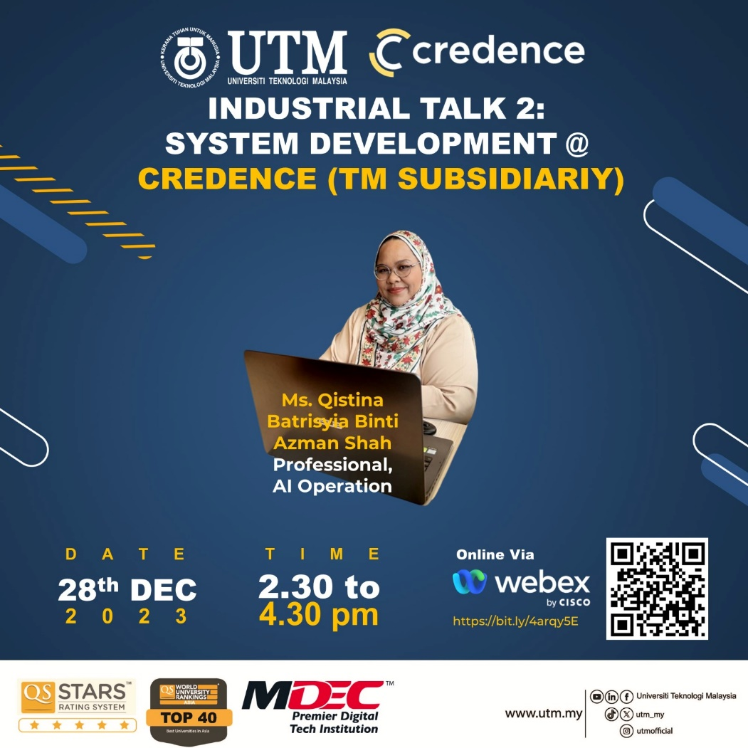

Poster for Industry Talk 2

## Instruction:

1. Students are required to prepare **A REPORT**.
2. The length of the **REPORT** **SHOULD NOT EXCEED 3 PAGES**:
3. Page one: This is the cover of the REPORT; it should include a proper title and a representative picture. The cover page should also include the titles for the topics covered in the REPORT and names of group member.
4. Pages two and three should include:

* Industry Talk 2 [**28 December 2023] System Development @ Credence (TM Subsidiary**). The content should consist of:description of the system development, history, technology and tool use in Credence’s system development.
* The reflection [each student] from the talk. How you will be a system developer in the next four years?

**\*\*Note**: The content of your report is your own opinion and views. You may refer the rubric of report in the next page.

1. The report will contribute **7%** of the course assessment.
2. Follow the **format of** report as follows:
   1. Justify alignment for text description.
   2. Include the date in each page.
   3. Design your report using your own creativity.
3. You may refer to the following links as your reference for designing your **REPORT**:
4. [https://www.flipsnack.com/templates/](https://www.flipsnack.com/templates/%20)
5. <https://design.tutsplus.com/t/tutorials/search/report+template>
6. <https://dribbble.com/tags/report-template>
7. **PLAGIARISM** of the content is prohibited. If any of the content is known to be copied from other website/review/blogs, you will be given **0 mark**.
8. You can get photos/information from other resources, but you must include credits (in citation/link) to the original owners.

**Rubric for Report (7%)**

| **Criteria** | **Excellent**  **10-7** | **Fair**  **6-4** | **Poor**  **3-0** | **WEIGHTAGE** | **MARKS** |
| --- | --- | --- | --- | --- | --- |
| **Informative and Attractive** | * Provide accurate information (Content). * All required information is presented in a logical order. | * Some information (Content) is inaccurate, but presented in a logical order. * Very few required information is missing and presented in a logical order. | * Most Information (Content) are inaccurate, or not presented in a logical order, making it difficult to follow. * Most required information is missing and not presented in a logical order, making it difficult to follow. | 10 | ____ X 10  10 |
| **Contents** | Page one:  This is the cover of the REPORT; it should include a proper title and a representative picture. The cover page should also include the titles for the topics covered in the REPORT and names of group member.  Pages two and three should include:  Industrial Talk 2 **[28 December 2023] System Development @ Credence (TM Subsidiary).**  The content should consist of:description of the system development, history, technology and tool use in system development.  The reflection [each student] from the talk. How you will be a system developer in next four year? | | | 30 | ____ X 30  10 |
| * All contents included * Very good presentation of content and well organized. * Use many graphics, pictures. | * Included but not well covered * Moderate presentation of content and well organized * Use moderate graphics, pictures. | * Included but poorly covered * Lack of content and not organized properly. * Use inappropriate graphics or pictures. |  |  |
| **Reflection** | The reflection [each student] from the talk. How you will be a system developer in next four years? | | | 30 | ____ X 30  10 |
| * Excellent explanation. | * Fair explanation. | * Poor explanation. |
| **Report Features** | * Include all required features, such as main report, graphics with captions and reporters. * All features relate to the subject and are appropriate for the targeted audience. * The layout is creative. | * Not all required features, such as main report, graphics with captions and reporters. * All features are almost related to the subject and are appropriate for the targeted audience. * The layout shows some degree of creativity but is not organized logically and/or is cluttered. | * Lack of features, such as main report, graphics with captions and reporters. * All features are unrelated to the subject and are inappropriate for the targeted audience. * The layout is messy, disorganized or cluttered. | 10 | ____ X 10  10 |
| **Organization and Structure** | * Structure of text is interesting and organized very well, easy to understand. | * Structure of text is quite interesting and organized. | * Most parts of the structure of text are not really interesting and unorganized. | 10 | ____ X 10  10 |
| **Text** | * All texts are easy to read and clear explanation. * Use appropriate font size. * Use not more than three different font styles. | * Most texts are easy to read and clear explanation. * Use appropriate font size. * Use more than three different font styles. | * Some texts are difficult to read unclear explanation. * Use medium font size. * Use more than four different font styles. | 5 | ____ X 5  10 |
| **Timeliness** | * Due date on time submission. | * Due date one day late submission. | * Due date more than one day late submission. | 5 | ____ X 5  10 |
| **Total** | | | | | / 100 |